To explain the outliers in the dataset, lets first clarify what these terms mean

* Global Outliers: They are data points that deviate significantly from the entire dataset. These points are extreme when compared to all the data.
* Context Outliers: They are data points that may seem unusual only in certain context, such as specific time periods, groups, or settings, but not in the dataset as a whole

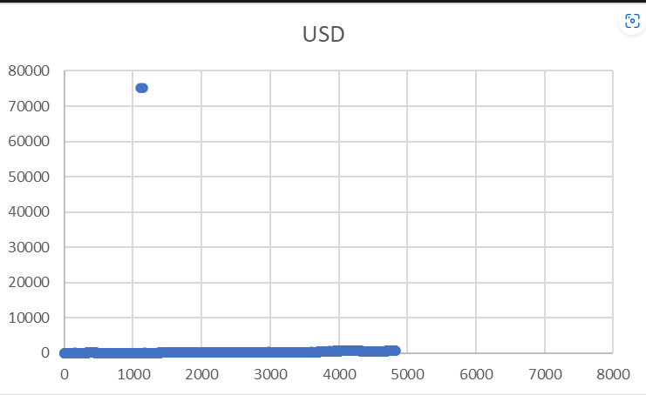

The scatter plot above shows a significant concentration of data points below 5000 with a prominent outlier around 80000. The data point near 80,000 clearly stands out as a global outlier.